**Lab Overview**

[Azure Machine Learning designer](https://docs.microsoft.com/en-us/azure/machine-learning/service/concept-designer) (preview) gives you a cloud-based interactive, visual workspace that you can use to easily and quickly prep data, train and deploy machine learning models. It supports Azure Machine Learning compute, GPU or CPU. Machine Learning designer also supports publishing models as web services on Azure Kubernetes Service that can easily be consumed by other applications.

In this lab, we will be compare the performance of two binary classifiers: Two-Class Boosted Decision Tree and Two-Class Logistic Regression for predicting customer churn. The goal is to run an expensive marketing campaign for high risk customers; thus, the **precision** metric is going to be key in evaluating performance of these two algorithms. We will do all of this from the Azure Machine Learning designer without writing a single line of code.

**Exercise 1: Create Training Pipeline**

Task 1: Open Sample 5: Binary Classification – Customer Relationship Prediction

1. In [Azure portal](https://portal.azure.com/), open the available machine learning workspace.
2. Select **Launch now** under the **Try the new Azure Machine Learning studio** message.

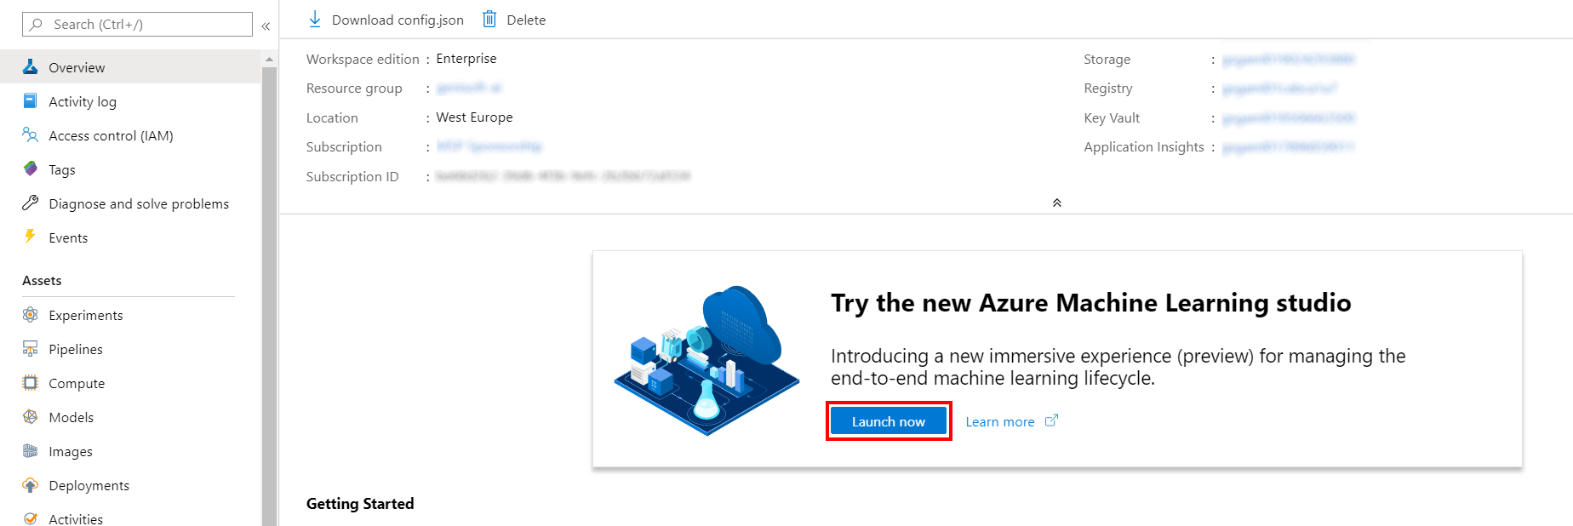

1. When you first launch the studio, you may need to set the directory and subscription. If so, you will see this screen:

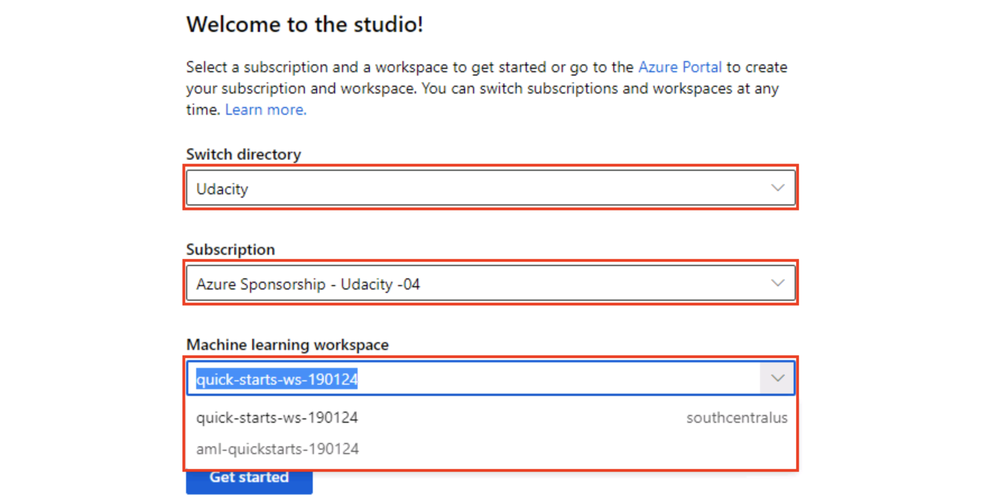

For the directory, select **Udacity** and for the subscription, select **Azure Sponsorship**. For the machine learning workspace, you may see multiple options listed. **Select any of these** (it doesn’t matter which) and then click **Get started**.

1. From the studio, select **Designer, Sample 5: Binary Classification – Customer Relationship Prediction**.

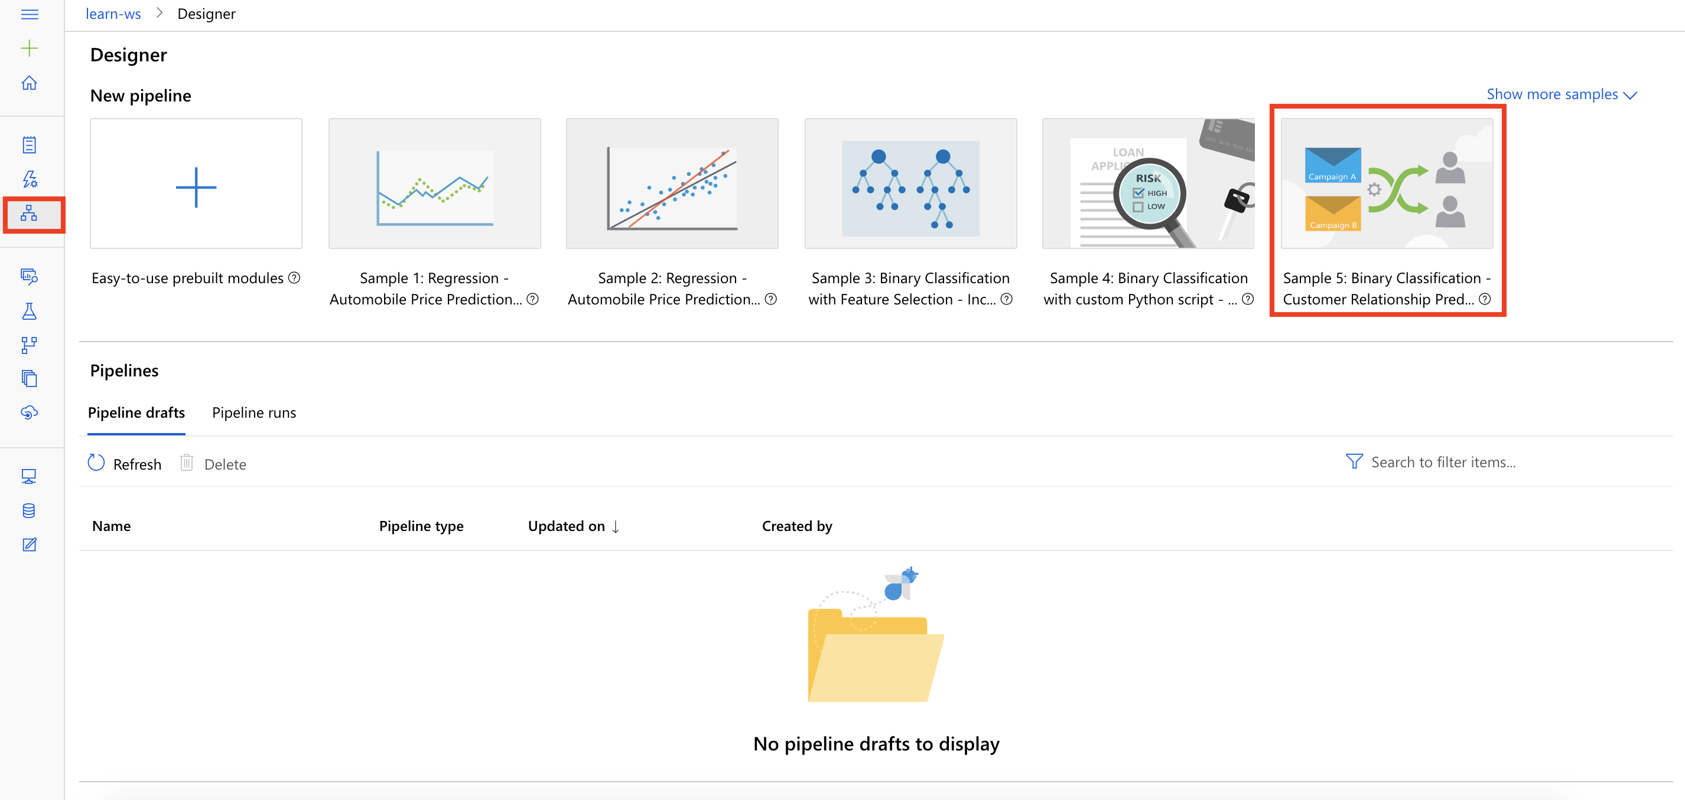

Task 2: Setup Compute Target

1. In the settings panel on the right, select **Select compute target**.

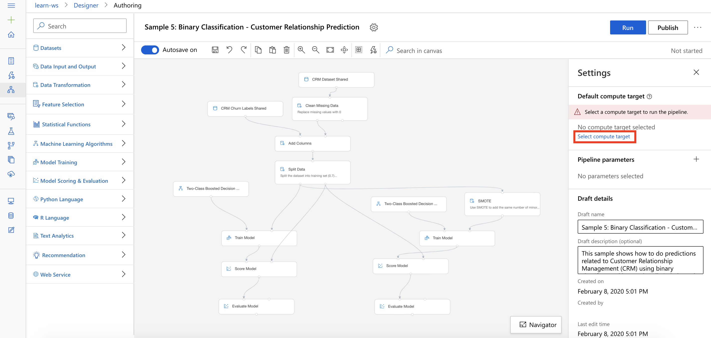

1. In the Set up compute target editor, select the available compute, and then select **Save**.

Note: If you are facing difficulties in accessing pop-up windows or buttons in the user interface, please refer to the Help section in the lab environment.

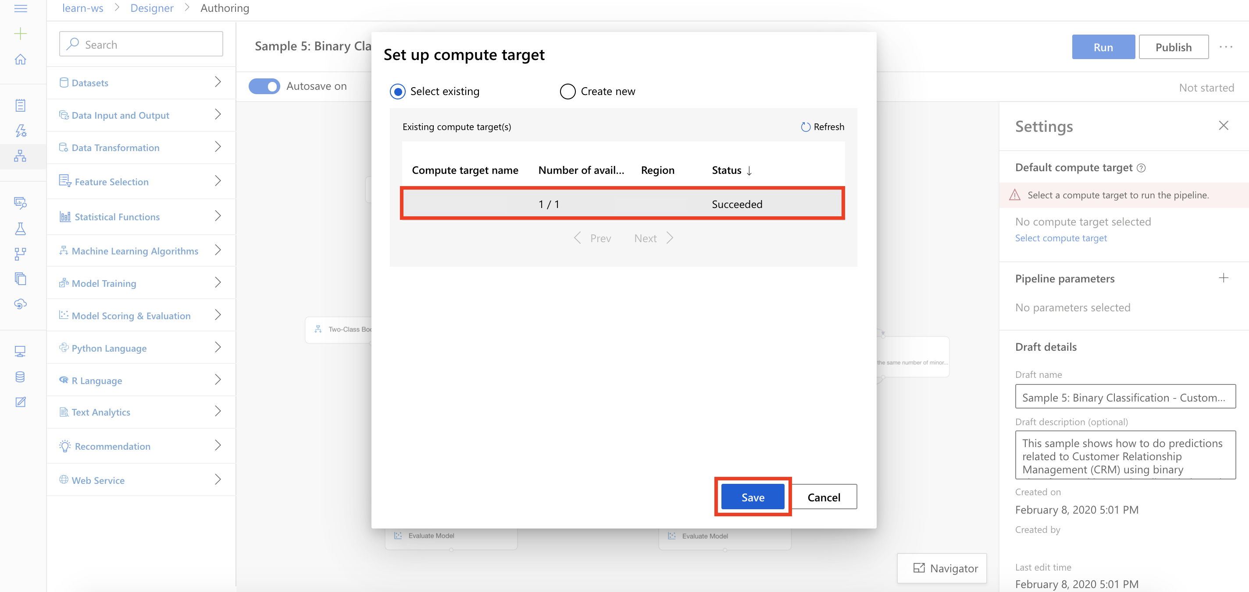

Task 3: Delete Pipeline Modules

1. From the right-hand-side of the pipeline, select the **Two-Class Boosted Decision Tree module** and then select the **Delete Icon**.

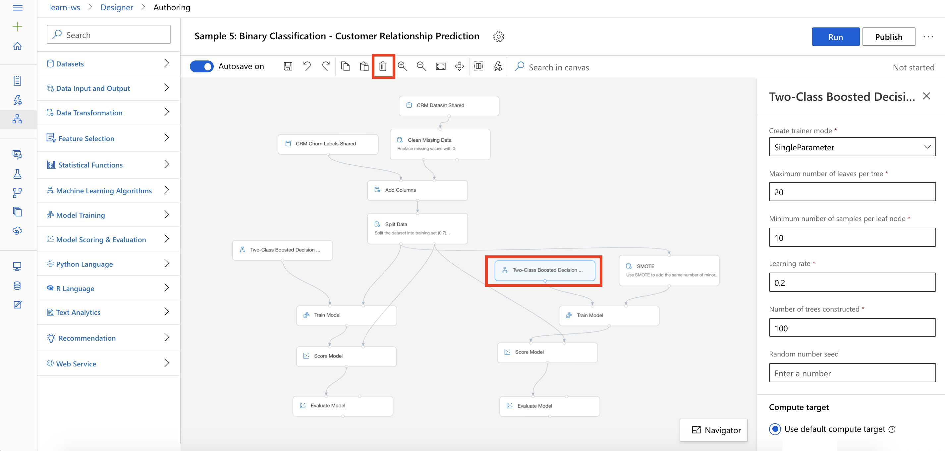

1. From the right-hand-side of the pipeline, select the **SMOTE module** and then select the **Delete Icon**.

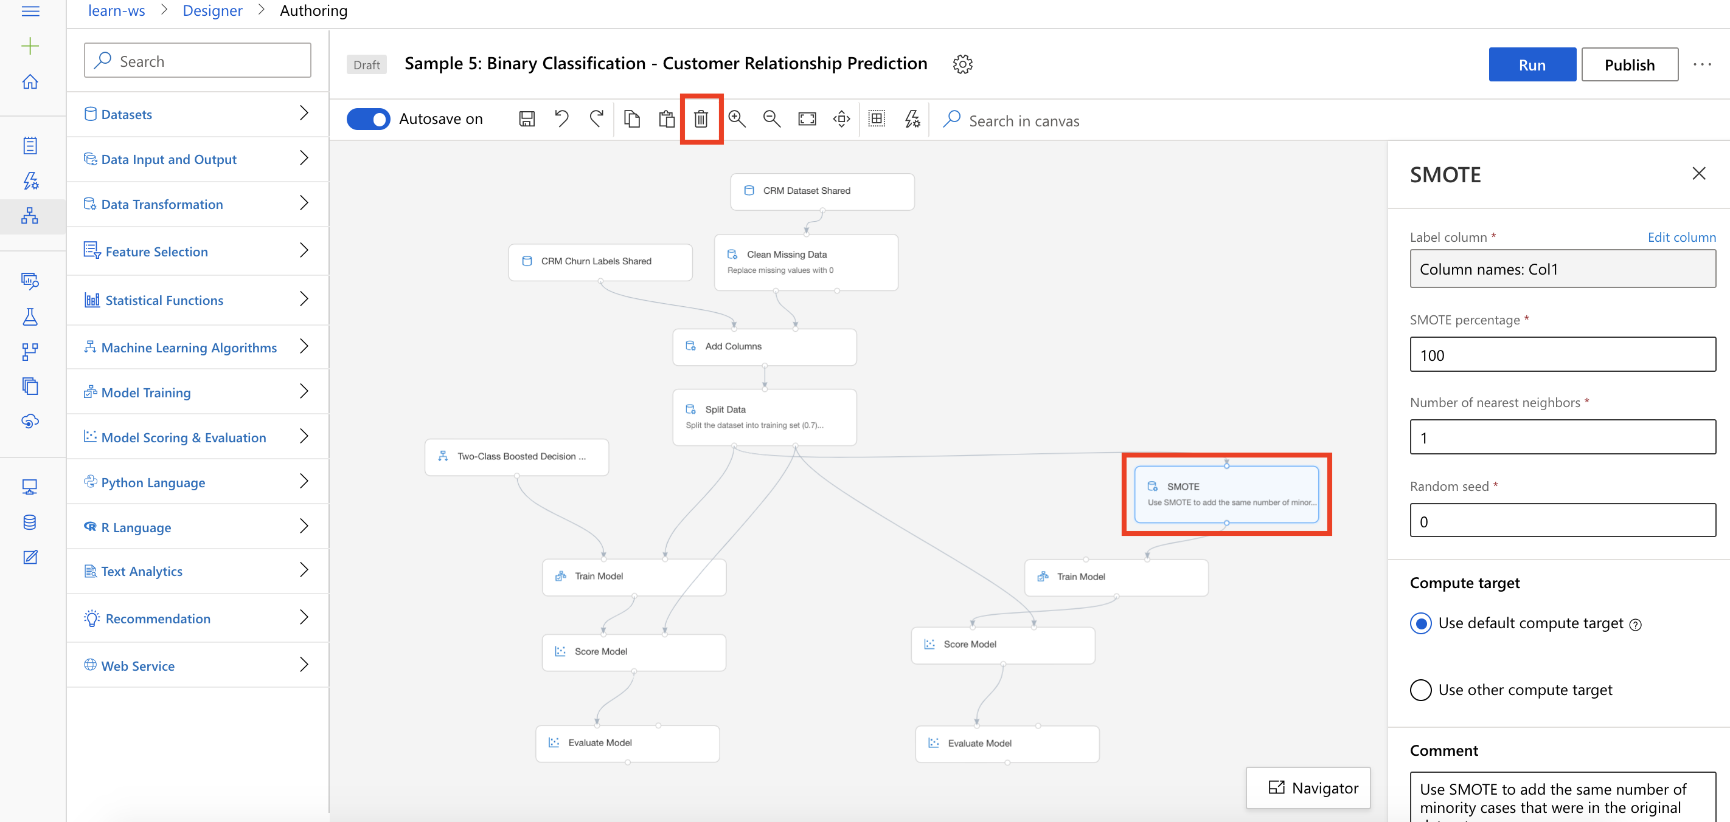

Task 4: Setup the Two-Class Logistic Regression Module

1. Select **Machine Learning Algorithms** section in the left navigation. Follow the steps outlined below:
   1. Select the **Two-Class Logistic Regression** prebuilt module
   2. Drag and drop the selected module on to the canvas
   3. Connect the Two-Class Logistic Regression module to the first input of the Train Model module
   4. Connect the first output of the Split Data module to the second input of the Train Model module

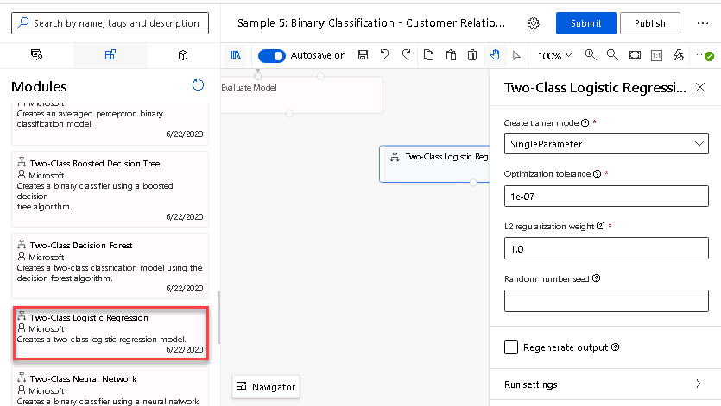

**Exercise 2: Submit Training Pipeline**

Task 1: Create Experiment and Submit Pipeline

1. Select **Submit** to open the Setup pipeline run editor.

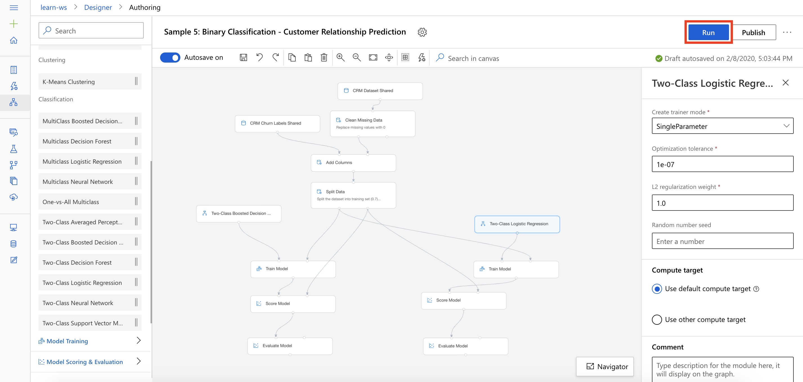

Please note that the button name in the UI is changed from **Run** to **Submit**.

1. In the Setup pipeline run editor, select **Experiment, Create new** and provide New experiment name: **Churn-Predictor**, and then select **Submit**.

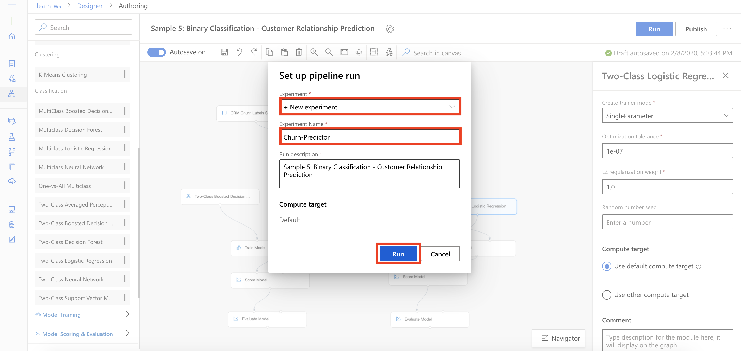

1. Wait for pipeline run to complete. It will take around **5 minutes** to complete the run.
2. While you wait for the model training to complete, you can learn more about the evaluation metrics for the classification algorithm used in this lab by selecting [Metrics for classification models](https://docs.microsoft.com/en-us/azure/machine-learning/algorithm-module-reference/evaluate-model#bkmk_classification).

**Exercise 3: Compare Model Performance**

Task 1: Open Evaluation Results for Two-Class Boosted Decision Tree

1. From the left-hand-side of the pipeline, select **Evaluate Model, Outputs, Visualize** to open the Evaluate Model result visualization dialog for the Two-Class Boosted Decision Tree module.

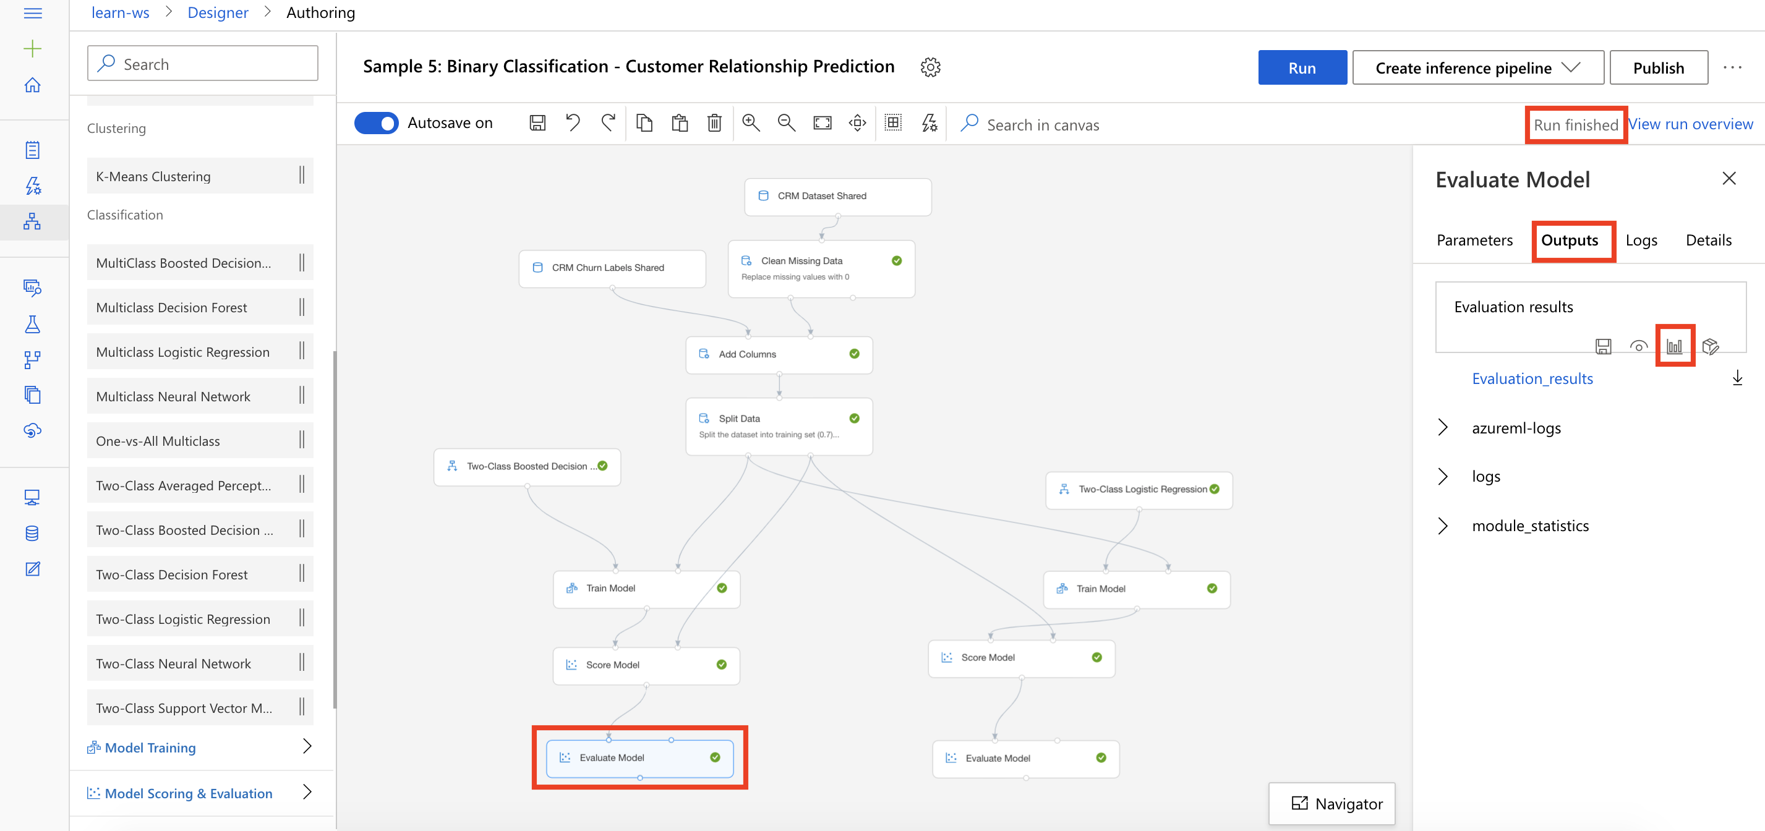

Task 2: Evaluate Two-Class Boosted Decision Tree Performance

1. Scroll down to review model performance metrics for Two-Class Boosted Decision Tree. Observe that the **Precision** value is around **0.7**.

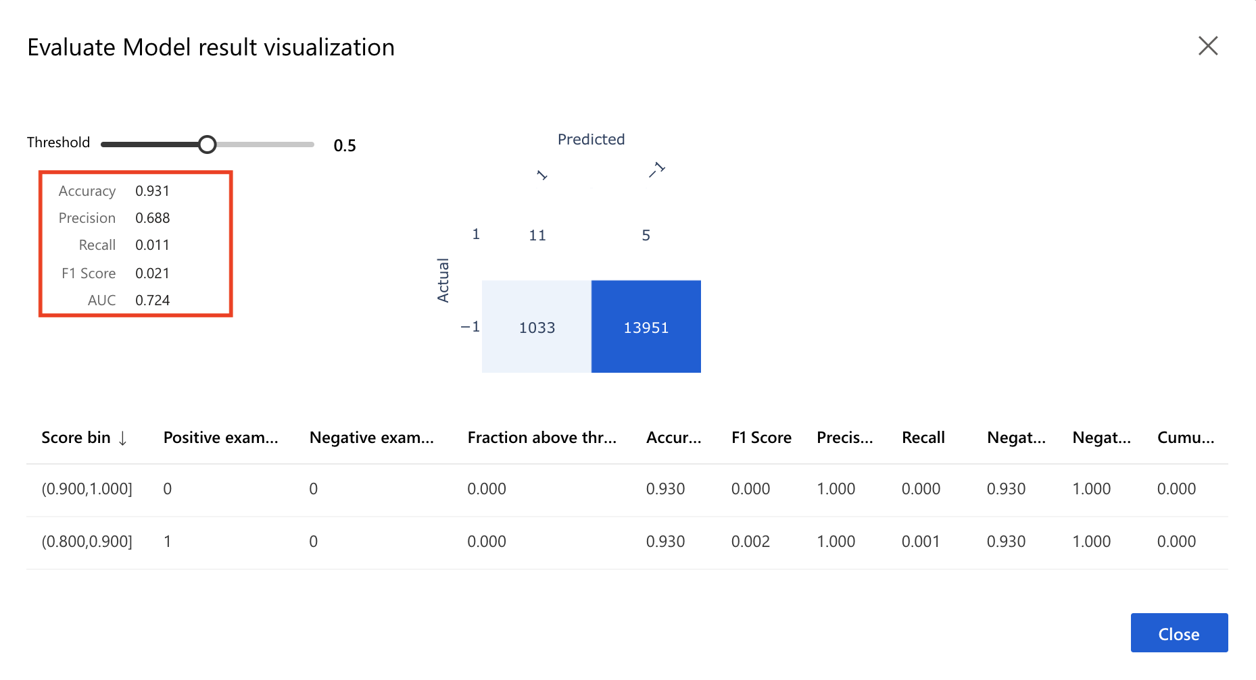

Task 3: Open Evaluation Results for Two-Class Logistic Regression

1. From the right-hand-side of the pipeline, select **Evaluate Model, Outputs, Visualize** to open the Evaluate Model result visualization dialog for the Two-Class Logistic Regression module.

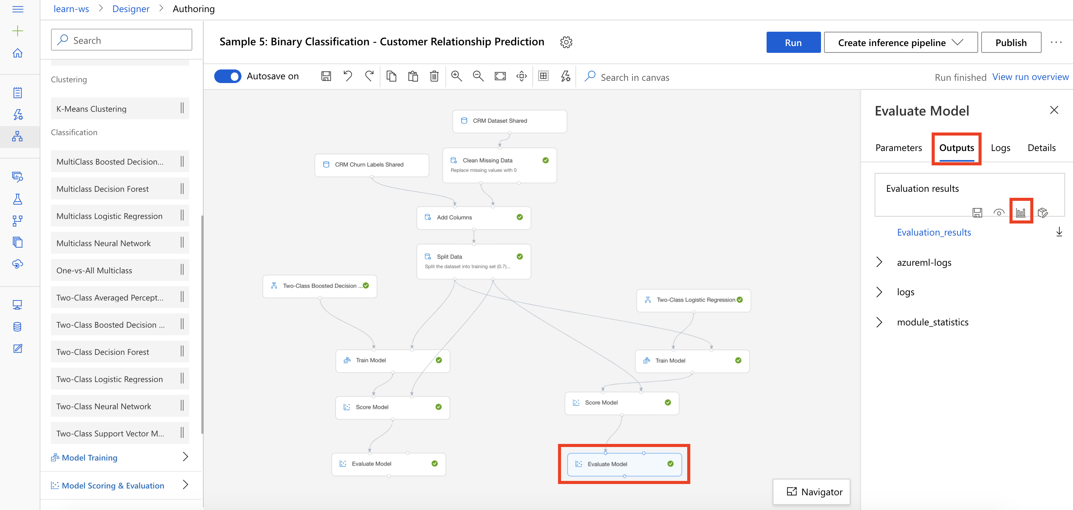

Task 4: Evaluate Two-Class Logistic Regression Performance

1. Scroll down to review model performance metrics for Two-Class Logistic Regression. Observe that the **Precision** value is around **0.3**.

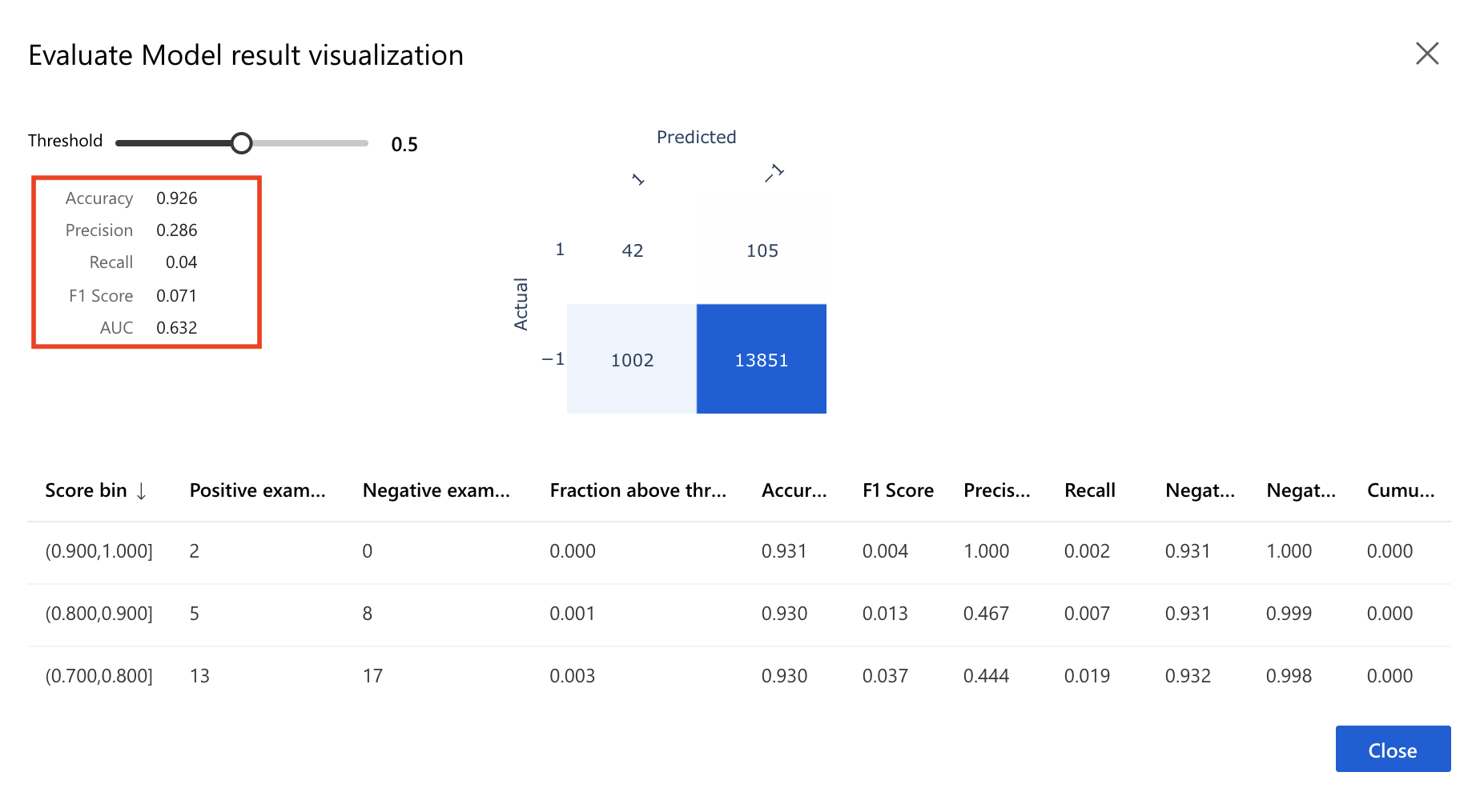

Task 5: Conclusion

1. Based on the primary performance metric, Precision, it shows that the Two-Class Boosted Decision Tree algorithm outperforms the Two-Class Logistic Regression algorithm.

**Next Steps**

Congratulations! You have trained and compared performance of two different classification machine learning models. You can continue to experiment in the environment but are free to close the lab environment tab and return to the Udacity portal to continue with the lesson.